**ASSIGNMENT NO-10**

* **Problem Statement:-** Deploy a project from github to EC2 by creating new security group and user data.
* **Steps:-**

# Security groups creation:-

1. 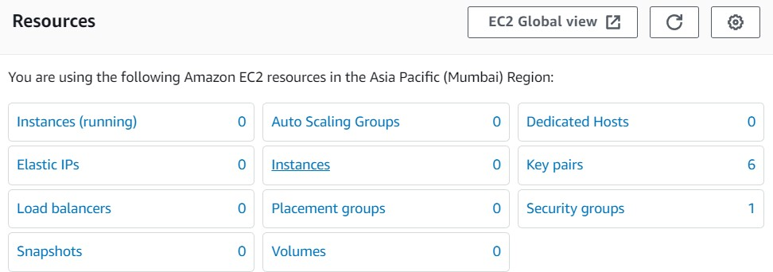Go to EC2 dashboard and click on **“Security groups”.**
2. Click **create Security groups** .Give name(ex-hsm48),description.

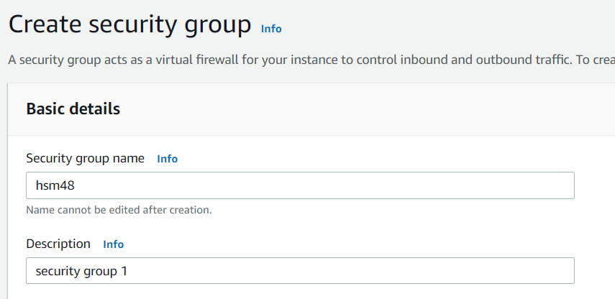

1. In inbound rules, click add rule and in type give custom TCP,SSH,HTTP,HTTPS and port range will be 4000 for custom TCP and the others are by default and in Source all are **anywhere public IPv4**.

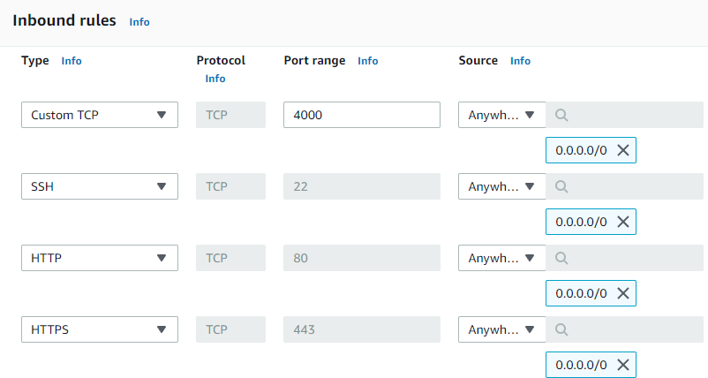

Now, click create Security group and the group will be created.

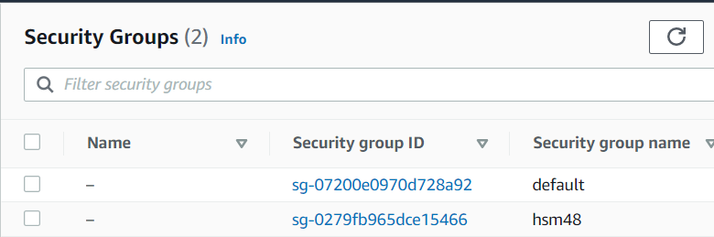

# EC2 creation:-

1. 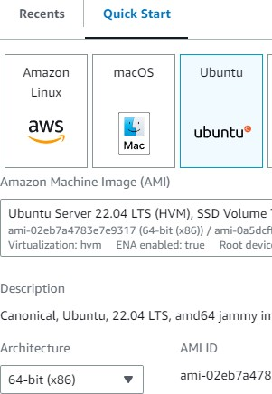In EC2 dashboard click **launch instances**. Give name,select **ubuntu** for hardware, architecture is 64-bit, instance type is t2.micro.

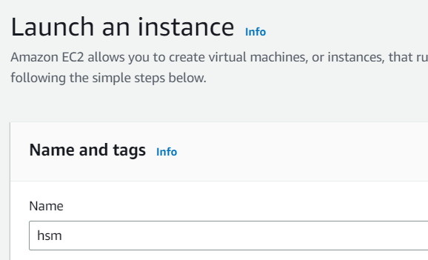

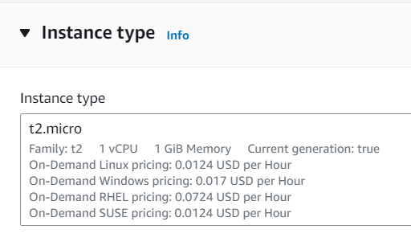

1. Give key pair(in case if u have it give existing one). In Network settings Firewall section click **select existing security group** and select the security group which is created previously(ex-hsm48).

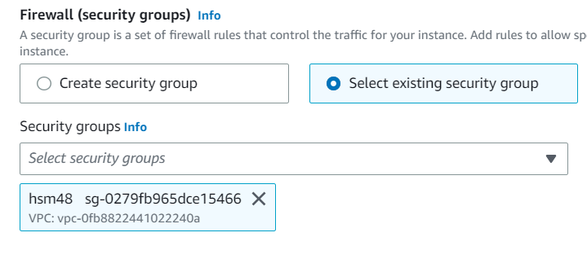

1. In Advance details , User data section type the following commands-

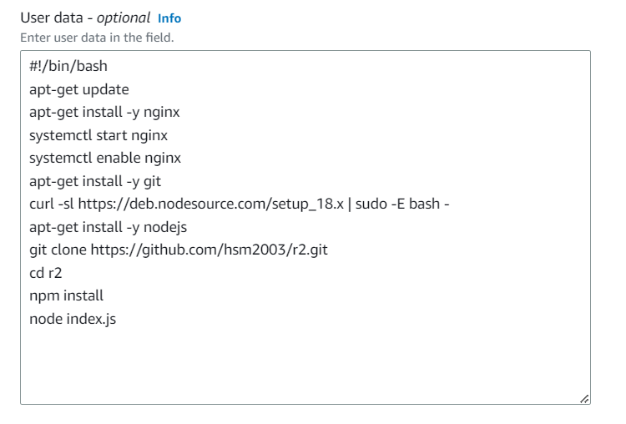

(In git clone line user can give his repo name and cd line the repo name will be according to his repo name.)

Now, click launch instances and the instance will be created.

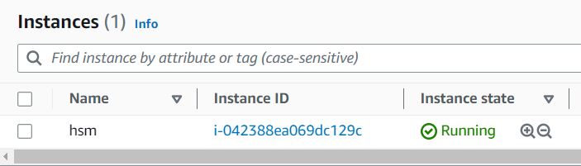

Now, copy public IPv4 address and run it with :4000 and we will get the website.

